**VISVESVARAYA TECHNOLOGICAL UNIVERSITY**

**JNANA SANGAMA, BELAGAVI**



**Synopsis**

**on**

**“Smart Car Parking Using Arduino Uno”**

submitted in partial fulfillment of the requirements of the award of the degree

**MASTER OF COMPUTER APPLICATIONS**

by

**SAURABH KUMAR**

**1MV21MC042**

**SHILPA A**

**1MV21MC043**

**Under the Guidance of**

**Mr. Raghavendra Rao**

**Asst. Professor**



**SIR M VISVESVARAYA INSTITUTE OF TECHNOLOGY Bengaluru-562157**

**ABSTRACT**

The project entitled SMART PARKING SYSTEM using Iot, the major motivation of this project is to reduce the traffic congestion in roads, multi-stored buildings and malls due to unavailability of parking spaces. The project displays the nearest empty slot if present with respect to user location. Our project aims to make efficient use of parking spaces. We track vacant slots in the parking space and assign that to the user. Smart parking system as described above can lead to an error-free, reliable, secure and fast management system. In recent times the concept of smart cities has gained great popularity. Thanks to the evolution of the Internet of things the idea of smart city now seems to be achievable. Consistent efforts are being made in the field of IoT in order to maximize the productivity and reliability of urban infrastructure. Problems such as, traffic congestion, limited car parking facilities and road safety are being addressed by IoT. The proposed Smart Parking system consists of an on-site deployment of an IoT module that is used to monitor and signalize the state of availability of each single parking space. A mobile application is also provided that allows an end user to check the availability of parking space and book a parking slot accordingly. The paper also describes a high- level view of the system architecture. Towards the end, the paper discusses the working of the system in form of a use case that proves the correctness of the proposed model.

# INTRODUCTION

The project entitled smart parking system is to manage all the parking facilities to a user. The recent growth in economy and due to the availability of low-price cars in the market, every average middle-class individual can afford a car, which is good thing, however the consequences of heavy traffic jams, pollution, less availability of roads and spot to drive the motor car. One of the important concerns, which is to be taken in accounting, is the problem of parking those vehicles. Though, if there is space for parking the vehicle but so much time is squandered in finding that exact parking slot resulting in more fuel intake and not also environment friendly. It will be a great deal if in some way we find out that the parking itself can provide the precise vacant position of a parking slot then it'll be helpful not limited to the drivers also for the environment

. Initially when the user is about to enter the location the LCD displays the number of empty and filled spots and when the user is with its vehicle near to the parking detect sensor, he/she would be thrown with a notification on their mobile app of the parking slot number, where they should park their vehicle.

**HARDWARE AND SOFTWARE SPECIFICATION**

## Hardware Specifications

* + - ENODE MCU (ESP8266)
    - JUMPER WIRES
    - INFRARED SENSORS
    - 16*2 LED DISPLAY
    - DC MOTOR

## Software Specification

ARDUINO IDE

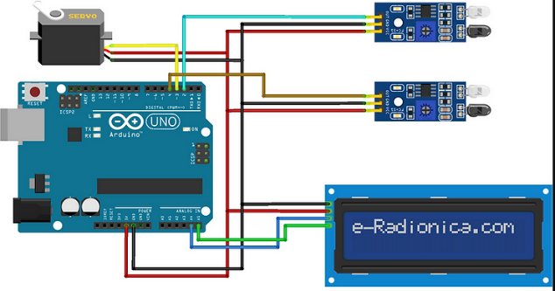

**Signature**

**-------------------------**

Mr. Raghvandra Rao

Asst. Professor Dept. of MCA